.
This research project explores how Artificial Intelligence (AI) works, why it appears mysterious to people, and what real risks versus myths surround modern AI systems. The primary focus is on understanding complex topics such as the black-box problem, emergent behavior, safety mechanisms, and public misconceptions about AI.

This research was conducted by Dhroov Dogra. It reflects both independent analysis and informed opinions, supported by a study of multiple online articles, academic explanations, and real-world examples. In addition, this work draws from discussions and practical interactions with AI systems to better understand how people perceive and use AI in everyday life.

The purpose of this research is not only to explain AI in technical terms but also to make it understandable to general readers, students, and young researchers. Special attention is given to ethical concerns, platform safety, and how responsible AI development can prevent misuse, such as harmful bots or privacy violations.

..
“Unveiling the Black Box: Emergent Behavior and AI Myths”
Artificial Intelligence (AI) has rapidly evolved, showing remarkable capabilities that often surprise both experts and the general public. This paper explores two key aspects of AI that contribute to its mysterious reputation: emergent behavior and the black-box problem. Emergent behavior refers to the AI demonstrating abilities or solutions that were not explicitly programmed, while the black-box problem highlights the difficulty of fully understanding complex neural networks and their decision-making processes. The paper also addresses common misconceptions and fears surrounding AI, including concerns about job loss, autonomy, and potential dangers. By analyzing scientific literature, real-world examples, and public perception, this research clarifies how AI functions, distinguishes fact from myth, and explains why AI is not inherently dangerous. This paper aims to provide a clear, accurate, and educational perspective on AI for students and interested readers.

...
How ChatGPT work
- ChatGPT works by learning patterns from a very large amount of text. It does not think like a human or understand the world in a real sense. Instead, it predicts the next word based on the words you have already typed.
- When you ask a question, ChatGPT analyzes the structure, meaning, and context of your sentence, and then generates a response by choosing the most likely next words, one after another. This process happens very fast, which makes it feel like the AI is “thinking,” even though it is actually performing advanced pattern matching.
- ChatGPT was trained on books, articles, conversations, and other text sources. During training, it learned how language works, how people explain ideas, how arguments are formed, and how questions are answered. However, it does not remember personal conversations and does not have access to private data unless the user provides it directly.
- Most importantly, ChatGPT does not have intentions, emotions, or awareness. It simply follows the instructions given by its developers and the rules set in its safety guidelines. What it says depends on both the user’s prompt and the ethical limits built into the system.

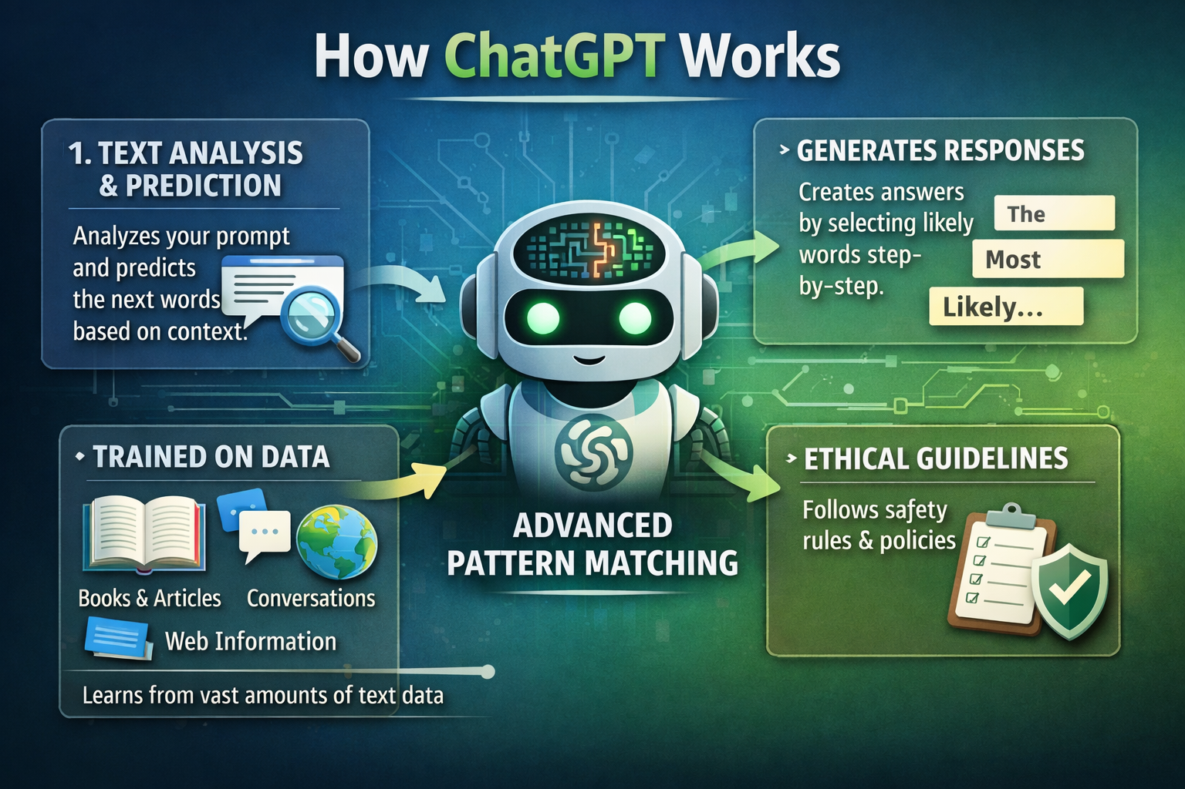....
So what is confusion and what Ai is dangerous?
- Many people are confused and worried that ChatGPT stores all our conversations forever or secretly listens through the microphone. Some content creators spread this idea to gain attention, but there is no official proof or real case showing that ChatGPT secretly listens to users or misuses private conversations.
- From my personal experience, I use AI for more than half of my work, and I have never faced anything suspicious. No unknown calls, no strange ads, no signs that someone is listening. If AI were truly spying, millions of users would have reported serious issues by now — but that has not happened.
- It is important to understand the difference between AI misuse and hacking or cybercrime. If someone’s phone is hacked or their data is stolen, that is a security issue caused by hackers, not by AI itself. Blaming AI for cybercrime is like blaming a calculator for a bank robbery — the tool is not the criminal.
- In conclusion, AI is not dangerous by default. Fear is often created by misinformation and sensational content, not by real evidence. Instead of spreading panic, we should focus on digital safety, strong passwords, trusted apps, and responsible use of technology.

.....
Eliminating Harmful AI Bots: A Scientific Approach to Platform Safety and Regulation
AI itself does not spread information or create harmful content on its own. The real problem arises when people develop unsafe or unethical AI systems — such as Telegram bots that leak private information or generate inappropriate images. These are not examples of responsible AI, but rather cheap or poorly designed tools created without ethical standards.


To prevent the development of AI systems that generate harmful or non-consensual images, companies must implement multi-layered technical, legal, and ethical safeguards at every stage of the AI lifecycle.
1. Safety-First Model Architecture
- AI models should be designed with built-in safety constraints, including:
- Hard-coded content filters
- Restricted prompt interpretation
- Internal classifiers that detect and block harmful intent
- These safety systems must be embedded at the model architecture level, not added later.
2. Secure Model Distribution and Licensing
- Open access to powerful generative models should be controlled, not unrestricted. Companies should:
- Use secure APIs instead of releasing full model weights
- Enforce strict licensing agreements
- Legally prohibit safety filter removal or misuse
3. Dataset Governance and Ethical Training
- All training data must follow:
- Consent-based data collection
- Privacy compliance laws (GDPR, etc.)
- Automated audits to remove sensitive, personal, or exploitative data
- This ensures the model never learns harmful patterns.
4. Continuous Monitoring and Abuse Detection
- AI systems must include:
- Real-time monitoring of usage patterns
- Automated detection of abnormal or malicious behavior
- Rapid suspension systems for accounts or applications showing abuse signals
5. Platform-Level Enforcement
- App stores, messaging platforms, and hosting services should:
- Require AI compliance certification
- Perform security audits before approving AI apps
- Remove bots that violate ethical or legal standards
6. Global Safety Standards and Regulation
- Governments and international bodies should:
- Establish AI safety regulations
- Mandate ethical compliance for deployment
- Penalize companies that release unsafe AI tools

......
“The Black Box Problem in Artificial Intelligence: Understanding the Unknown”

Many researchers have already studied and discussed the “black box” nature of artificial intelligence. For example, Professor Samir Rawashdeh from the University of Michigan explains that deep learning systems work by learning patterns from large numbers of examples, much like how humans learn. However, even though these systems can make accurate decisions, we often do not know exactly how they reach those conclusions.
He describes this as a situation where the system “loses track” of which inputs shaped its final judgment. In other words, the AI gives an answer, but the internal reasoning process remains unclear to humans. This is why modern AI systems are often called “black boxes” — we can see the input and output, but not the full decision pathway inside.
This research shows that the black box problem is not a new concern. It has already been recognized by experts in artificial intelligence and engineering. My work builds on these ideas by analyzing whether this lack of transparency is truly dangerous, or whether it can be managed through better design, regulation, and ethical guidelines.

What Is Black box problem🤔?.

- The black box problem refers to the fact that many modern AI systems, especially deep learning models, make decisions in ways that humans cannot fully understand or explain.
We know :
  - What data goes in, and what result comes out,but we often don’t know what happens in between.That hidden internal process is why these systems are called “black boxes.”
Why Does This Happen?
  - AI models learn by analyzing huge amounts of data and finding patterns. Over time, they adjust millions (or even billions) of internal connections. These connections become so complex that even the people who build the models cannot trace exactly how a specific decision was made.This is not because AI is secretive —it’s because the system is too complex for direct human interpretation.

Why Is This a Problem?

- The black box issue becomes serious when AI is used in:
- Healthcare decisions
- Hiring and job screening
- Loan approvals
- Legal systems
- In these cases, people deserve to know why a decision was made, not just what the decision is.
- Without transparency, it becomes difficult to:
- Check for bias
- Ensure fairness
- Build trust in AI systems
- Does the Black Box Mean AI Is Dangerous?
- Not necessarily.
- Humans also make many decisions without being able to explain every mental step. For example, we recognize faces instantly but cannot describe exactly how our brain does it.
- Similarly, the black box problem does not mean AI is harmful —
it means we need better tools for explanation and accountability.
What Is Being Done About It?
Researchers are actively working on:
- Explainable AI (XAI)
- Tools that show which data influenced a decision
- Models designed to be more transparent by design

"Okay, I know that you understand from my points above that AI is harmless, so now let’s go deeper into the black box problem.”🙄

“The concept of the ‘black box’ predates modern artificial intelligence and originally comes from systems theory and cybernetics. Early researchers, such as Norbert Wiener, described complex systems where only the inputs and outputs could be observed, but the internal processes remained hidden. In the context of AI, the black box problem became prominent with the development of neural networks in the 1980s and 1990s. As networks grew larger and more complex, it became increasingly difficult for even the developers to fully explain how specific decisions were made. This challenge escalated in the 2000s with the rise of deep learning models, pioneered by researchers like Geoffrey Hinton, Yann LeCun, and Yoshua Bengio, whose systems achieved unprecedented performance but limited interpretability. Today, the black box problem remains a central issue in AI research, motivating the fields of explainable AI (XAI) and model interpretability.”

Why AI Seems Mysterious to the People.
- One reason AI seems mysterious to people is the way it generates content, such as images. Modern AI models, like DALL·E or MidJourney, create pictures by analyzing millions of existing images and learning patterns in shapes, colors, and styles. When you give a prompt, the AI doesn’t copy a single image — instead, it predicts what a plausible new image would look like based on all the patterns it has learned.
From the user’s perspective, this process seems almost magical. You type a description, and in seconds, a fully formed image appears. However, the actual process is highly complex: the AI uses layers of artificial neurons, probabilities, and pattern recognition that even the developers cannot fully trace for each individual image.
This combination of highly accurate output and hidden internal processes makes AI feel mysterious. People see only the result, not the intricate “thinking” that went into it, which contributes to the perception that AI is unpredictable or even “magical.”

How AI Image Creation Is a Highly Complex Process

- When AI generates an image, it doesn’t just “draw” like a human. Instead, it goes through millions of calculations in a few seconds. Modern AI models, such as DALL·E or Stable Diffusion, use deep neural networks—layers of artificial neurons that mimic some aspects of the human brain.

- Each neuron processes input, weighs it, and passes it to the next layer. With hundreds of layers and millions of neurons, the AI decides which shapes, colors, textures, and patterns make the final image. These decisions are based on probabilities learned from huge datasets, not a step-by-step instruction.

- Because there are so many layers and connections, even the developers cannot fully trace why the AI chose a specific pixel or color. This hidden process is what makes AI highly complex and mysterious—it is predictable in general, but untraceable in the details.

.......
The Story of AI Getting a Voice.

The story of how AI acquired a human-like voice begins with the field of speech synthesis, which dates back to the mid-20th century. Early experiments involved mechanical devices and simple computers that could generate basic sounds and words, but the voices were robotic and unnatural. With the advent of digital computing and machine learning, researchers began feeding AI systems with massive datasets of human speech, covering diverse accents, emotions, and speaking styles.
Using these recordings, AI learned the patterns of speech: how individual sounds (phonemes) combine to form words, how intonation conveys meaning, and how rhythm and timing create natural sentences. Modern AI models, such as Text-to-Speech (TTS) neural networks, process written text and predict the corresponding sound waves, effectively “speaking” in a way that mimics human speech.
Today, AI voices can express emotions, vary tone, and even imitate real people, creating a sense of personality and presence. While the underlying process is highly complex and invisible to users, the result feels seamless and intuitive. This evolution from mechanical sounds to realistic, expressive voices explains why AI speech still feels mysterious to many: the technology is incredibly advanced, yet the reasoning behind every nuance of sound remains hidden inside the model.

Shakey the Robot: The Story of the First Mobile AI Robot.
The history of artificial intelligence and robotics includes many milestones, but one of the most important early achievements was the creation of Shakey the Robot — widely recognized as the world’s first mobile robot to combine physical action with autonomous reasoning. Developed at the Artificial Intelligence Center of the Stanford Research Institute (SRI International) between 1966 and 1972, Shakey fundamentally transformed the fields of robotics, AI, and computer science, laying the groundwork for future generations of intelligent machines.

Inspiration and Origins.
Before Shakey, most robots were simple machines that followed pre-programmed sequences of actions. They could perform repetitive physical tasks, such as assembly line movements, but could not make decisions about what to do next based on what they observed. In the early 1960s, researchers led by Charles A. Rosen proposed the idea of a robot that could perceive its environment, reason about goals, plan a sequence of actions, and carry them out without step-by-step instructions. This concept was revolutionary, moving robotics closer to the idea of a machine with true artificial intelligence.

Funding and Early Challenges.
Securing support for this idea was not easy. The research proposal submitted to the Defense Advanced Research Projects Agency (DARPA) in 1964 faced skepticism because intelligent mobile robots existed mostly in science fiction at the time. For nearly two years, Rosen and his team worked to convince funding agencies of the scientific value of building such a machine. Eventually, DARPA awarded SRI a research contract in 1966 to begin the work on what would become Shakey.
Design and Tools Used.

The development of Shakey required the integration of several cutting-edge technologies, both in hardware and software. The robot’s physical form was simple but functional: a tall, wheeled base that allowed it to move through its environment. It was equipped with a television camera, sonar range finders, collision detectors (“bump sensors”), and an antenna for two-way communication with remote computers. These sensors allowed Shakey to “see” and sense its surroundings, essential for autonomous navigation.
On the software side, Shakey was programmed primarily using LISP, a language popular in early AI research because of its ability to manipulate symbolic information efficiently. Its planning software used a system known as STRIPS (Stanford Research Institute Problem Solver), which enabled the robot to break down complex goals into sequences of actions the robot could attempt to perform. The architecture combined sensing, planning, and action in a way that had never been done before.

How Shakey Worked.

When Shakey received a high-level command from a human operator — for example, to “push a block off a platform” — the STRIPS planner would analyze the environment model and generate a high-level plan. This plan included steps like locating a ramp to reach the platform and pushing the ramp into position. While Shakey could not execute all these intermediate steps directly, its software could plan sequences of simpler actions (like moving forward, turning, pushing), monitor execution, detect errors, and adapt its behavior.

Because robots operate in the physical world, they must deal with unpredictable changes — objects move, sensors misread, and environments vary. Unlike previous theoretical AI systems that ended their task once a plan was printed, Shakey had to monitor real-world execution continuously, detect when something went wrong, and recover. Developing this capability was one of the major challenges of the project, requiring novel approaches in planning and control integration.

Major Technical Challenges

The Shakey project was far from straightforward. There were numerous obstacles that the research team had to overcome:
Computer Vision: At the time, image processing techniques were very rudimentary, and the concept of pixels was not widely used. Developing methods to extract meaningful information from low-resolution camera data required inventing new visual analysis techniques.

Navigation: Graph search algorithms existed, but adapting them to real-world navigation with obstacles was challenging. This led to the development of new algorithms and methods that became foundational in robotics.
Natural Language: One of the goals was to allow Shakey to understand commands in ordinary English. At the time, computational linguistics was in its infancy, and parsing natural language into actionable plans was a significant research problem.
Learning and Adaptation: Early approaches to machine learning, such as neural networks, were not advanced enough for Shakey’s tasks. Instead, researchers developed mechanisms for planning and generalizing action sequences to help Shakey reuse knowledge.
Political and Funding Hurdles: Beyond technical issues, the team also faced political and institutional challenges. SRI was not then a leading academic center for AI, and convincing peers and funders of the importance of such a complex robotics project took considerable effort.

Impact and Legacy

Shakey’s achievements were not limited to demonstrating a mobile robot with planning capabilities. The project produced innovations that have influenced numerous fields:
Algorithms: Techniques such as the A search algorithm* for pathfinding and the Hough transform for feature extraction in image analysis arose from the research around Shakey.
Software Architecture: Shakey’s layered control structure became a model for future autonomous systems, combining low-level actions with high-level planning in a modular way.
Modern Robotics and AI: Many systems derived from Shakey’s principles — from autonomous vacuum cleaners like Roomba to self-driving vehicles and even Mars rovers — use technologies and algorithms inspired by Shakey’s design.
Recognition: Shakey has been honored with prestigious awards, including an IEEE Milestone in Electrical Engineering and Computing, and was inducted into the Robot Hall of Fame. It is also on display at the Computer History Museum, reflecting its historical importance.

........
Actual Risks vs Myth.

Artificial Intelligence (AI) has become an essential part of modern society, influencing areas such as healthcare, education, communication, and industry. However, public understanding of AI is often shaped by misinformation, fear, and exaggerated claims. This paper aims to distinguish between the actual risks of AI and the popular myths surrounding it. Through analysis of existing research and public discourse, the study examines issues such as data privacy, algorithmic bias, misinformation, transparency, and employment transformation. At the same time, it addresses misconceptions regarding AI consciousness, surveillance, and autonomous control. The paper concludes that while AI presents genuine ethical and societal challenges, many fears are unsupported by evidence and can be addressed through responsible development, regulation, and public education.

Popular Myths About AI

.Many people believe AI can think like humans, listen to private conversations, or operate independently of human control. In reality, AI systems function through mathematical models and data-driven pattern recognition. There is no verified evidence that mainstream AI platforms engage in unauthorized surveillance. Additionally, AI does not eliminate all jobs but rather transforms labor by automating certain tasks while creating new opportunities.
Actual Risks of AI

AI presents real challenges that require attention. These include data privacy risks, algorithmic bias, misinformation through synthetic media, lack of transparency in decision-making (the black box problem), and over-reliance on automated systems. These risks arise not from AI itself, but from how it is designed, deployed, and governed.

Impact on Employment

AI primarily automates routine and repetitive tasks. However, it also creates new professions in technology, research, and ethics. Human-centered skills such as creativity, emotional intelligence, leadership, and moral judgment remain beyond the capabilities of AI and continue to define the value of human labor.

. Ethical Responsibility and Governance

AI developers, organizations, and governments share responsibility for ensuring ethical use. This includes implementing safety policies, preventing harmful applications, protecting data privacy, and establishing regulatory frameworks. Platform accountability is essential to prevent misuse and ensure compliance with ethical standards.

.........
Safety Mechanism in AI.

As Artificial Intelligence systems continue to improve through learning and adaptation, concerns arise regarding their ability to modify themselves or create similar systems. Although AI can update its models and optimize performance over time, it does not autonomously replicate or create new versions of itself without human authorization. This limitation is enforced through safety mechanisms such as access control, model deployment restrictions, human oversight, and secure infrastructure.
Uncontrolled self-replication could introduce risks related to system instability, security vulnerabilities, and ethical accountability. Therefore, AI development emphasizes human-in-the-loop frameworks, version control, and regulatory compliance to ensure that any system updates or expansions occur only under supervised conditions.
Furthermore, the structured and high-stakes environment of space exploration highlights the importance of controlled AI deployment. In space missions, AI can be safely utilized for navigation, system monitoring, scientific analysis, and autonomous decision-support, while remaining within strict operational constraints. Using AI in such regulated environments allows society to benefit from its learning capabilities without risking uncontrolled behavior.
In conclusion, while AI systems evolve through continuous learning, strong safety mechanisms ensure that they remain under human control. The future of AI should focus on responsible development, supervised adaptation, and deployment in environments where safety, transparency, and accountability are prioritized.

............


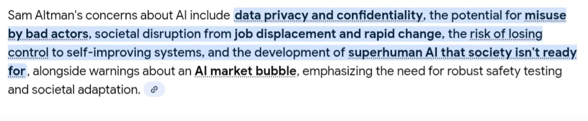E


